H.T No
Regulations:
A18

Sreenidhi Institute of Science and Technology
(An Autonomous Institution)
Code No: 7K301 Date: 09-Oct-2021(FN)

B.Tech II-Year I- Semester External Examination, Sept/Oct-2021 (Supplementary)
INTRODUCTION TO SOLID MECHANICS-I (CIVIL)

Time: 3 Hours Max.Marks:70

Note: a) No additional answer sheets will be provided.
b) All sub-parts of a question must be answered at one place only, otherwise it will not be valued.
c) Missing data can be assumed suitably.

ANSWER ANY 5 OUT OF 8 QUESTIONS. EACH QUESTION CARRIES 14 MARKS.

Bloom's Cognitive Levels of Learning (BCLL)

Remember | L1 | Apply | L3 | Evaluate | L5
Understand | L2 | Analyze | L4 | Create | L6

 |  |  | BCLL | CO(s) | Marks
1. | a) | A steel wire of 10mm diameter is used for lifting a load of 1 kN at its lowest end, the length of the wire hanging vertically being 200m. Taking the unit weight of steel = 78 kN/m³ and E = 2x10⁵ N/mm², calculate the total elongation of the wire. | L3 | CO1 | [7M]
 | b) | A steel column is 12cms in diameter and 3m long. Find the intensity of stress and the strain when it carries an axial compressive load of 95 tonnes.  Take E = 2 x 10⁶ kg/cm² | L3 | CO1 | [7M]
2. | a) | A cantilever of length 4m carries a uniformly distributed load of 1 kN/m run over the whole length and a point load of 2kn at a distance of 1m from the free end. Draw the S.F and B.M diagrams. | L3 | CO2 | [7M]
 | b) | Draw the SF and BM diagrams for the beam loaded as shown in figure.  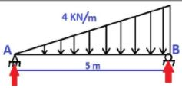 | L3 | CO2 | [7M]
3. | a) | A beam of triangular section has a base of width 15cm and an altitude of 9cm. if the section subjected to a shear force of 300 kg, find the maximum shear stress | L3 | CO3 | [7M]
 | b) | A square beam 20mm x 20mm in section and 2m long is supported at the ends. The beam fails when a point load of 400N is applied at the centre of the beam. What uniformly distributed load per meter length will break a cantilever of same material 40mm wide, 60mm deep and 3m long | L3 | CO3 | [7M]
4. | a) | An simply supported beam, 6m long carries a point load of 24 kN, 2m from the left end and another of 32kN is 5m from the same end. Calculate the slopes at the ends and the deflections under the loads using moment area method. Take E = 200 GN/m² and I = 800 cm⁴  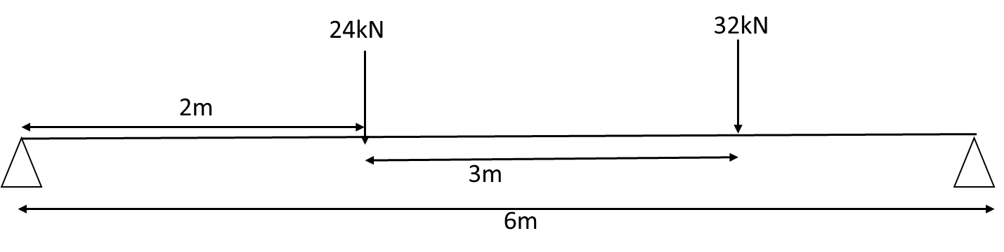 | L3 | CO4 | [7M]
 | b) | A beam of length 6m is simply supported at its ends and carries two point loads of 48kN and 40kN at a distance of 1m and 3m respectively from the left support. Find: (i) deflection under each load, (ii) maximum deflection and (iii) the point at which maximum deflection occurs. Given E = 2 x 10⁵ N/mm² and I = 85 x 10⁶ mm4 | L3 | CO4 | [7M]
5. | a) | A rectangular steel bar is subjected to a tensile stress of 800 kg/cm2 as well as a shear stress of 300 kg/cm2. Determine the principal stresses and the principal planes. Find also what stress acting alone cam produce the same maximum strain. take (1/m = 0.3). | L3 | CO5 | [7M]
 | b) | Draw a Mohr’s circle for a state of pure shear if Ƭ_{xy} = -60 MPa. Find the stresses on planes whose normal is inclined at 30 & 120 degrees to the x-axis. |  | CO5 | [7M]
6. | a) | Derive the Shear stress equation. | L2 | CO6 | [7M]
 | b) | Explain maximum shear stress theory. Derive the necessary equations to assess the failure. | L2 | CO6 | [7M]
7. | a) | Draw stress - strain curve for a mild steel rod subjected to tension and explain about the salient points on it | L2 | CO1 | [7M]
 | b) | What are the different types of beams? Differentiate between a cantilever and a simply supported beam. | L2 | CO2 | [7M]
8. | a) | Find the deflection at the centre of a simply supported beam (Lm) carrying a point load W at the centre. | L3 | CO4 | [6M]
 | b) | Explain with reasons which theory of failure is best suited for  - Ductile material  - Brittle material | L3 | CO5 | [8M]
-- 00 -- 00 –

